4.1. Modify the mutex version of the $π$ calculation program so that the critical section is in the for loop. Compare the performance of your version with the serial version.

4.2. Modify the mutex version of the $π$ calculation program so that it uses a semaphore instead of a mutex. Compare the performance of your version with the serial version.

Templates for 4.1 and 4.2 are provided, they both use timer.h to obtain the system time, and this head file is also provided.

4.3.

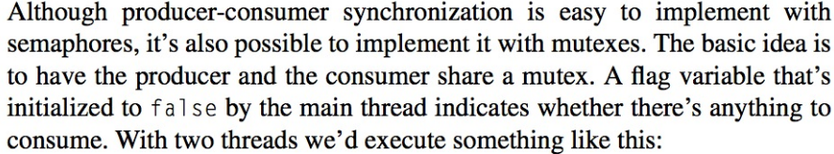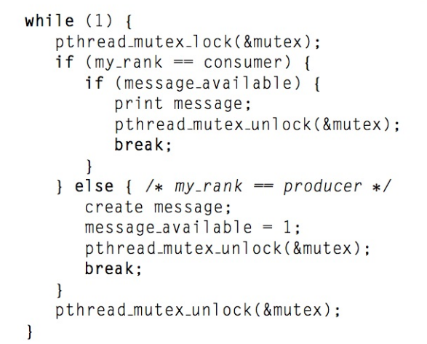

“4.3_pth_producer_consumer.c” provided is a **complete** Pthreads program that implements this version of producer-consumer synchronization with two threads.

**Suppose there is only at most one message at all time:**

declare a global variable *message* to print out the message “hello from xxx”.

1. Generalize this so that it works with 2*k* threads – odd-ranked threads are consumers and even-ranked threads are producers. Every odd-ranked thread must indicate that it receives message and also indicate which thread sends the message.

**Hint:** You can declare a global variable *msg* and then use it in the **while** loopto indicate that if the resource is ready to consume. There is no constraint which thread consumes the new resource as long as it is an odd-ranked thread.

1. Generalize this so that each thread is both a producer and a consumer. In particular, suppose that thread q “sends” a message to thread (*q* + 1) mod *t* and “receives” a message from thread (*q* − 1 + *t*) mod *t*, where *t* is the total number of threads. Every thread must indicate that it receives message and also indicate which thread sends the message.A close up of a logo
   
   Description automatically generated

**Hint:** You can declare global variables *msg* and *receiver,* then use them in the **while** loop:*msg* to indicate that if the resource is ready to consume, and *receiver* to indicate which thread shall consume the resource. You may also declare local variables *send* and *recv* within each thread to signify should it produce or consume, and the thread can only break the while loop to end itself after it has fulfilled its duty as both producer and consumer.